COS30045: Data Visualization Project Reflection

StudentID: 104182054
Student Name: Le Duc Tri
Course: COS30045
Tutor Name: Trung Nguyen

- Introduction
In order to convey complex data in an understandable and captivating manner, my partner and I worked together throughout the semester to create and develop an interactive data visualization project. Working with real-world datasets, implementing dynamic visual elements using D3.js, and making sure the finished product was both educational and easy to use were all requirements of the project. We ran into several technical difficulties along the process, especially while trying to debug intricate visual behavior and modify our strategy to produce more effective, clear visuals. These limitations forced us to work closely together, analyze critically, and iterate often. Therefore, the experience helped me build important teamwork and problem-solving skills that are crucial in any data-driven project, in addition to expanding my technical expertise.

My contribution: I’m personally love thinking logically, so I work on designing the responsive and interactive chart as well as make should it provided correct functionality. My work is testing the chart, discovering the dataset and knowing what and what shouldn’t represent to make sure it visualizes something meaningful.

- Constraint, Adapting and Learning
Constraint:
Throughout the project's development, I ran into several technological obstacles that at first made it difficult for me to move forward effectively. My inexperience with D3.js was a big problem, particularly when it comes to putting certain visualization elements like tooltip interaction, axis scaling, and transitions into practice. Another persistent issue was providing meaningful representations of missing or partial data, which necessitated careful visual encoding in addition to data cleansing. Additionally, the asynchronous nature of JavaScript and the intricacy of SVG manipulation in D3 made debugging issues frequently time-consuming. These limitations made the project's early phases challenging, requiring me to take my time and investigate the underlying reasons for mistakes or unsuccessful implementations rather than depending solely on trial and error.

Adapting:
I actively looked for online resources like Google searches, W3Schools lessons, and YouTube D3.js examples to get around these restrictions. My understanding of how different D3 functions operated and how to apply them to actual data was greatly aided by these platforms. I also looked at code snippets that the community has given and samples from the official D3 documentation. It was essential to work closely with my teammate in addition to studying on my own. We frequently discussed our discoveries, helped one another through challenging situations, and divided up the work according to our own strengths. We were able to maintain our pace and respond to obstacles more rapidly because of this cooperative approach. We gradually started adding more sophisticated elements, fixing graphic errors, and making sure our chart was understandable and accurate.

Experiences:
In addition to learning coding principles, this experience helped me build important soft skills like teamwork, flexibility, and rational problem-solving. Working under pressure to correct errors or modify design choices taught me to approach issues methodically rather than rashly. Additionally, I learned how to assign tasks to others, have clear conversations with teammates, and use feedback to make iterative improvements. Most significantly, I developed a greater understanding of the function of visualization in data communication. I realized that the viewer's understanding may be significantly impacted by the way numbers are presented, including scale, color, interaction, and space. This has increased my awareness of visual storytelling and reaffirmed how crucial precise, unambiguous data representation is in digital communication.
- Contribution to Project
Mapping data:
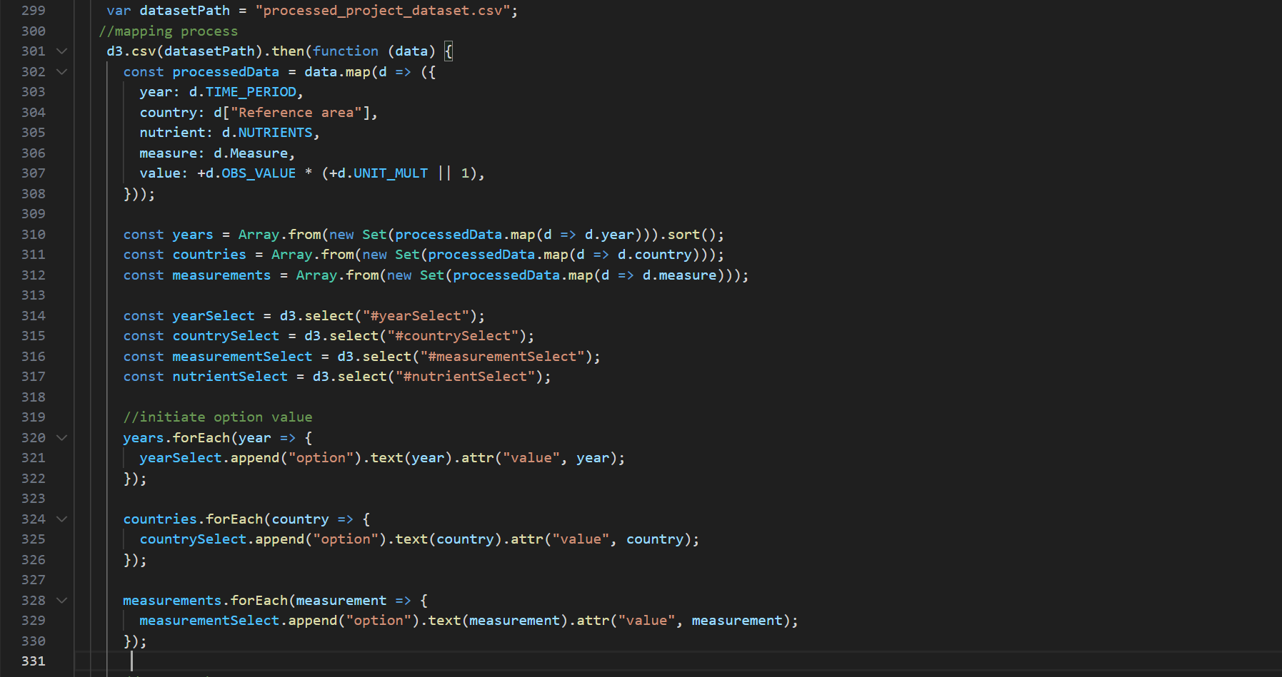
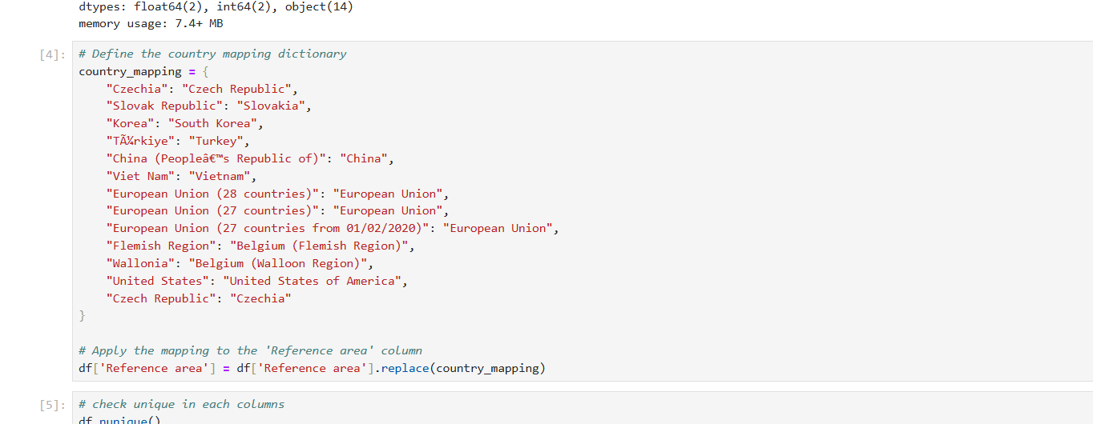
Mapping the data, which required both dataset organization and D3 integration, was one of my primary contributions to the project. Regarding the dataset, I preprocessed and rearranged the raw data into a format that could be used using programs like Excel. This involved segregating important columns, merging values as needed, and getting them ready for D3 to access. To make sure everything matched the design purpose, I worked on more than 200 lines of thorough data descriptions and categorizations. By connecting the data to SVG elements, I created mappings between the dataset and visual elements on the D3 side. To achieve accurate and readable visualization, this necessitated carefully connecting data elements to graphical properties like bar height, axis ticks, colors, and labels. In this image I handle both on codes and when I was mapping for geojson file.

Cleaning data:
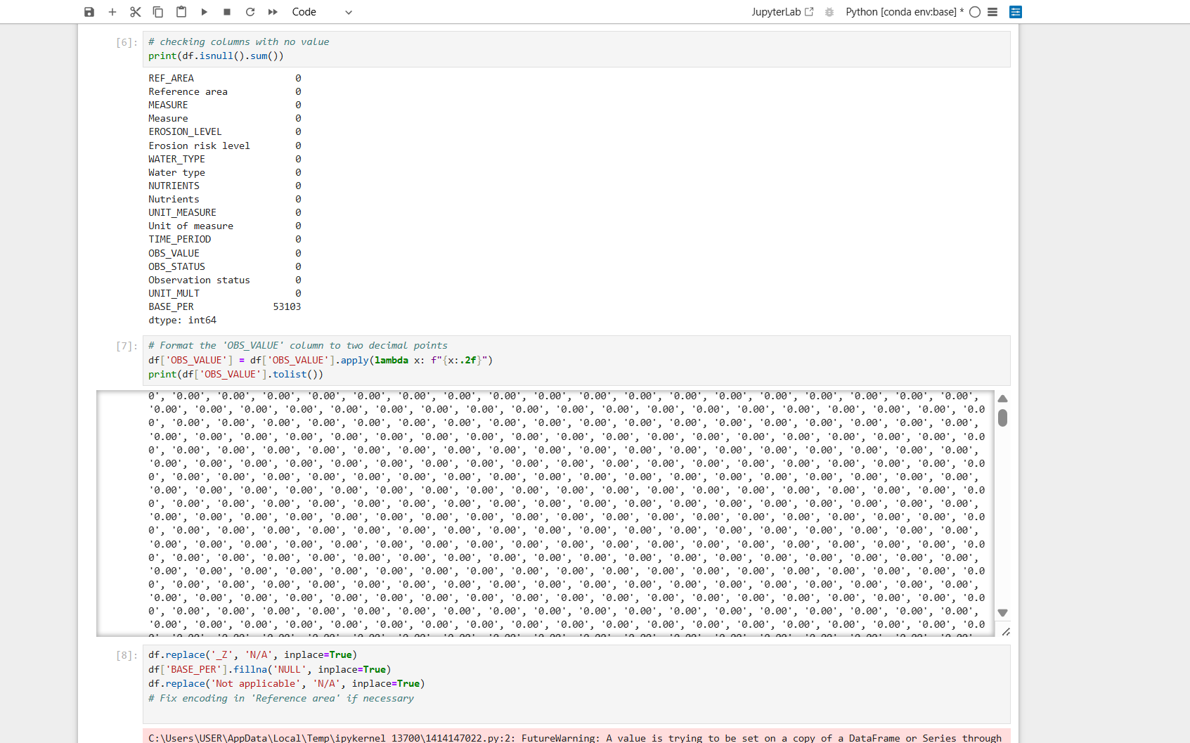
One of the most important tasks I completed to guarantee the accuracy and significance of the visualizations was cleaning the dataset. In order to reduce complexity and load time, I started by eliminating columns that weren't relevant to our ideas. Additionally, I changed some display settings, such as transforming numerical codes into legible percentages or category names. Mapping the dataset's nation names to those used in a GeoJSON file for map-based visualization was one of the most difficult tasks. I had to manually match and modify a lot of entries because of variations in name practices. In order to prevent mismatch mistakes, this transformation procedure required meticulous attention to detail, particularly when working with different data sources or statistics specific to a given country.
For example, there is some data like this need to be handled 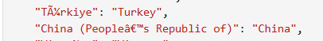

Code functionality development:
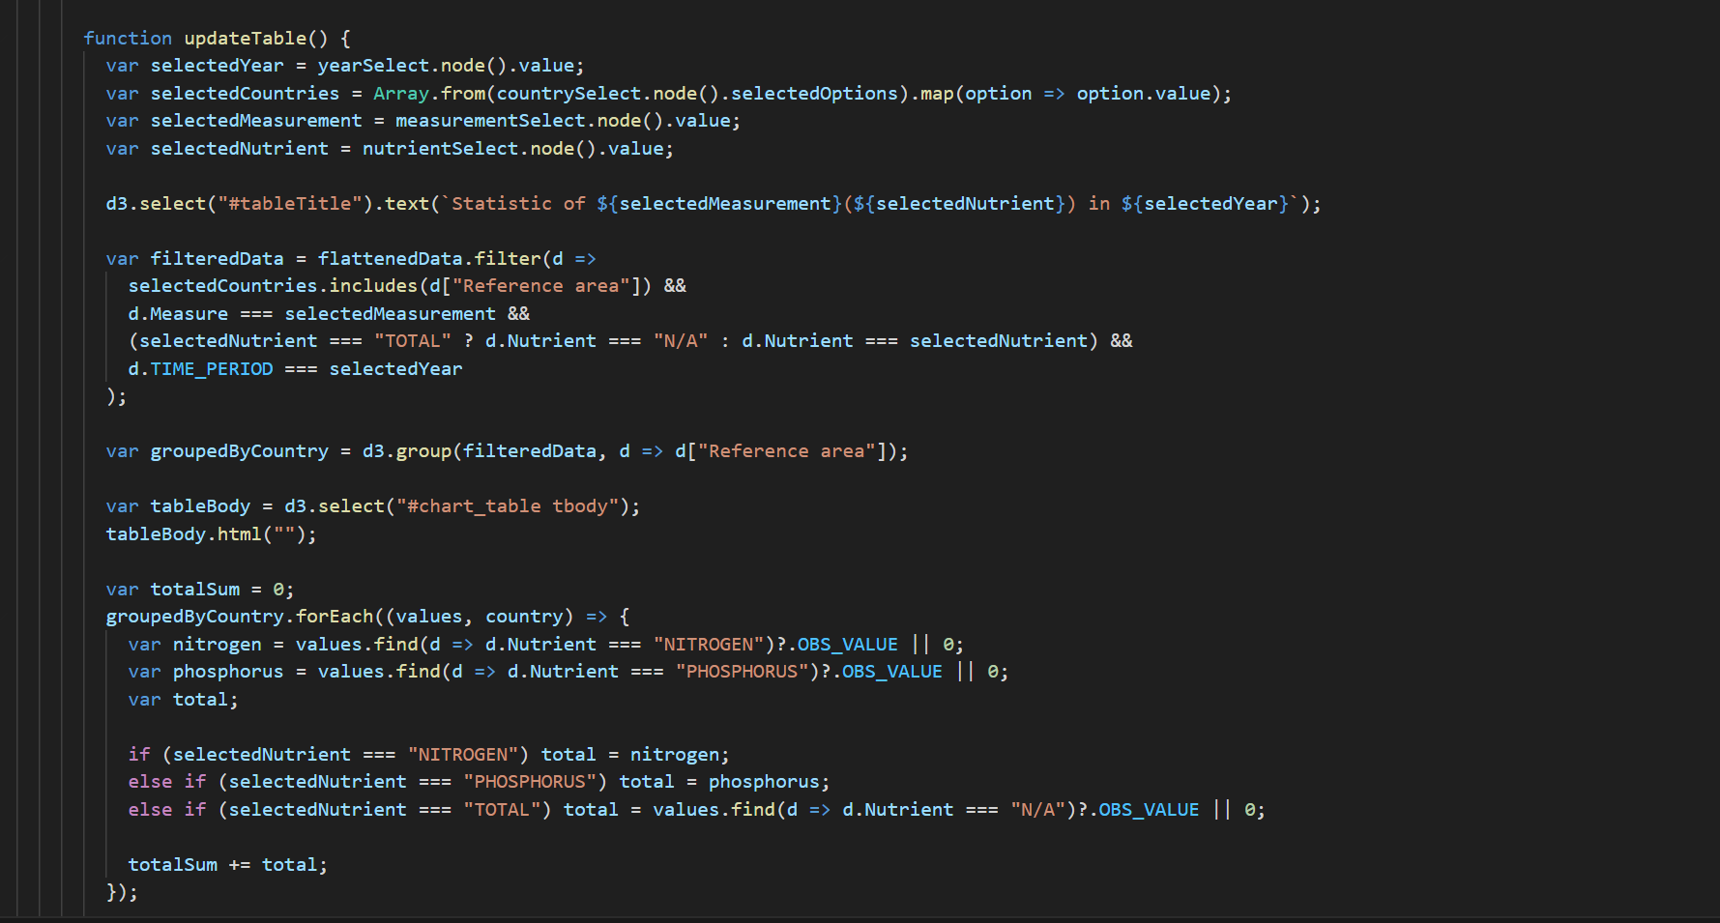
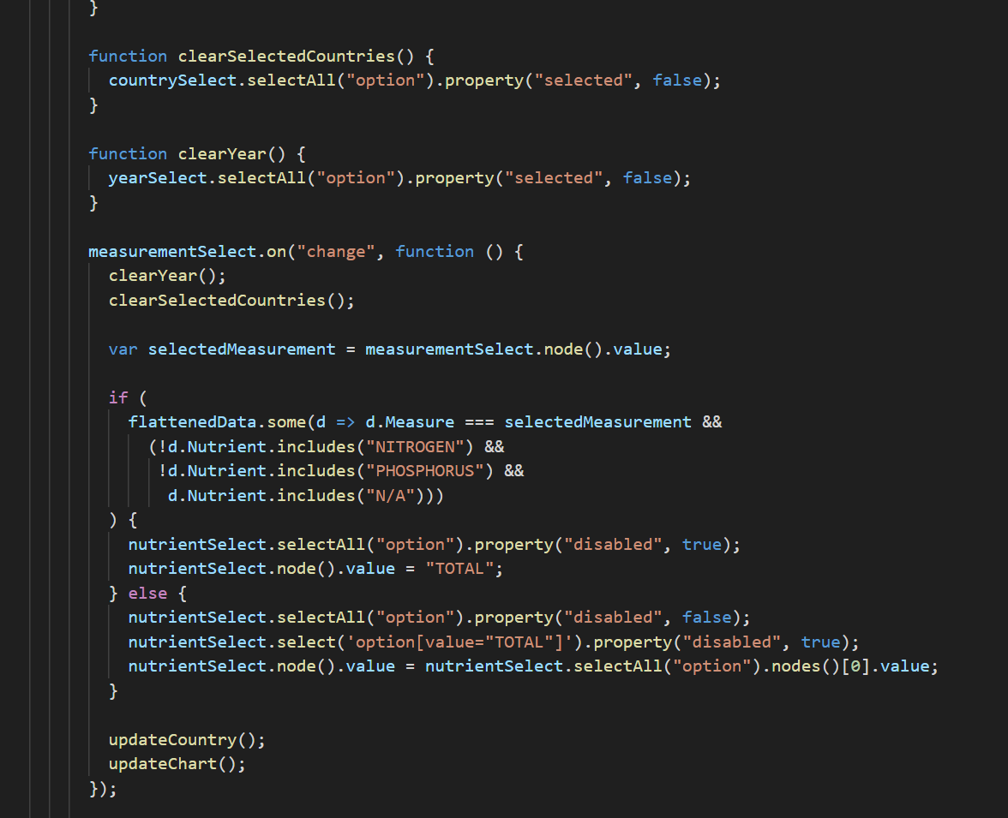
I had a major role in creating visualization’s main features. I had to take a logical approach to the coding and work on it piecemeal, always keeping in mind how each graph element would react to user input and evolving data. I spent a lot of effort creating conditional statements that would change the way values were shown, such as by dynamically updating labels, hiding zero values, or structuring huge numbers for readability. In order to ensure that the audience could understand the data, I also concentrated on the message that the visualization should be sent using color, location, and scale. These choices were supported by careful computations and condition-driven reasoning to produce significant, approachable outcomes. I developed multiple functions such as update table for example in the images which I need to manage situation where this function should be and why this function exists in the first place.

Error fixing and adaptation to requirements:
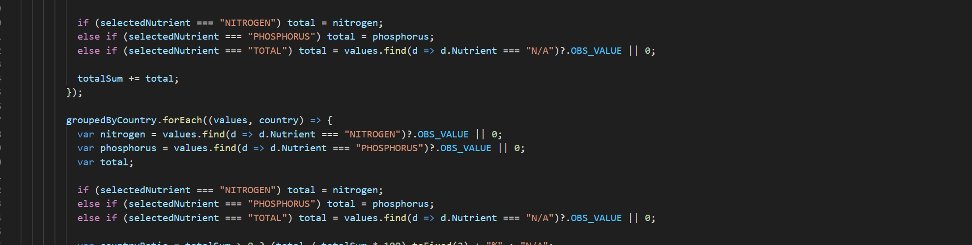
I regularly came across and fixed functional and visual mistakes during development. Some problems were caused by logical errors in the code, while others resulted from the way the data was structured or filtered. I frequently had to troubleshoot odd behaviors like labels overlapping or bars appearing wrongly. I tried a variety of methods to address issues, such as removing redundant or erroneous data, altering the update logic, and turning off unneeded components in particular situations. In order to change the chart scales, conceal blank areas, or display fallback messages, I also modified the interface using conditional logic. These fixes strengthened the visualization's resilience to changing circumstances while also enhancing the user experience. Making sure conditional statements logic are well written is one of my priorities.

- What I learned aligned with the unit outcome
Individual Reflection:
Throughout the development process, I personally ran across a lot of limitations, particularly when it came to comprehending and utilizing sophisticated D3.js features. I occasionally had trouble effectively implementing conditional rendering, transitions, and error handling. Managing unexpected behavior when the dataset changed dynamically—elements that overlapped or vanished for no apparent reason—was a common problem. These issues motivated me to conduct in-depth investigation. To obtain pertinent answers, I used a combination of official D3 material, internet discussion boards, Stack Overflow, YouTube tutorials, and W3Schools. Before implementing improvements for the real project, I experimented with simpler samples to identify and comprehend flaws.

I gained more technical knowledge of D3's data binding, update patterns, and SVG handling as well as improved debugging abilities because of this exercise. More significantly, I discovered how to tackle code problems logically as opposed to emotionally. Working independently to find problems, test fixes, and put improvements into place has given me more confidence. These experiences improved my ability to think logically and helped me understand how careful code and careful design work together to create a visual product that is driven by data.

Team Reflection:

We also encountered several cooperation limitations as a team. Sometimes delays or redundant efforts resulted from poor communication or differing levels of expertise. For instance, there were times when we worked on overlapping code segments or misinterpreted design goals, which caused issues with integration. We resolved these problems by dividing up the work more clearly and keeping each other informed of our progress through frequent meetings and shared papers. We would individually investigate solutions when one of us ran into a technical obstacle, like a new D3 method or a display issue, and then get together to compare methods. Our method became more effective because of this joint learning, which also created a positive work atmosphere.

I learned how to give and receive constructive criticism, actively listen, and modify my working style to play to my teammates' strengths. Additionally, I discovered how crucial modular code and version control are in a shared environment. All things considered, cooperation not only increased our technical productivity but also improved my capacity to work with others in a real-world project setting. These encounters strengthened the notion that, particularly when dealing with the kinds of difficulties that inevitably occur in creative and technical group work, communication and collaborative problem-solving are just as crucial as producing clean code.

- Conclusion on Data visualization
I have learned a lot from this data visualization project, which has tested me both intellectually and emotionally. I gained a better grasp of how to convert unprocessed data into understandable, interactive visualizations by utilizing D3.js to map, clean, and visualize real-world data. The difficulties I encountered, such as dealing with missing data and fixing display issues, strengthened my ability to solve problems and reaffirmed the significance of accuracy in data representation. Working with a teammate also taught me how to split tasks, communicate clearly, and adjust to common objectives. All things considered, this project enhanced my technical skills and broadened my understanding of how skillfully created visualizations can transform complicated data into understandable insights for people.

